**Lab 4 File System Management**

1. **Overview**

Main goals

• To understand basic concepts of filesystems, such as performance tuning and availability improvement.

• Partition management (format, mount, umount, join resize...).

• Extending File System size through logical volumes.

• Error protection (RAID systems) and recovery (Backup tools).

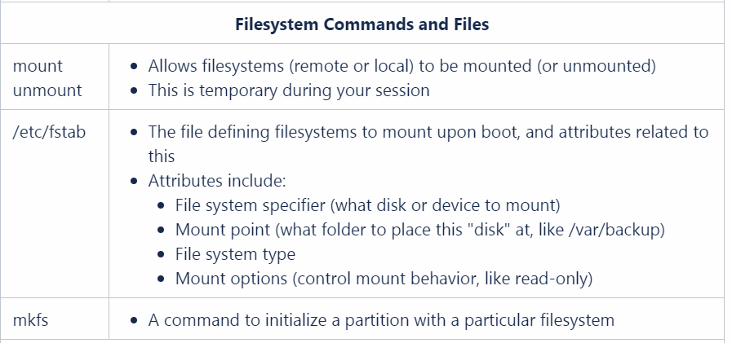

1. **Tutorial**
2. Checking the hard drives attached to your virtual machine, and find out its identifier (e.g., /dev/sda).
3. ls /dev
4. fdisk -l
5. Then ,shut down your virtual machine
6. sudo shutdown now
7. Make a new virtual disk in your virtual box or VMWare software
8. Checking out the new hard drives just built, and find out its identifier
9. ls /dev
10. sudo fdisk -l
11. If your new disk is /dev/sdb， you need to format the new disk. Here, we partition this disk into 2 partitions, and finally you will see /dev/sdb1, /dev/sdb2.
12. sudo fdisk /dev/sdb
13. Then, you will get a menu asking you to choose. If you don’t know anything, just input “L”, and see what happens. Actually, you could format and build a file system with this step.

t--- (for "change a partition type"),

1---(to select the first disk partition)

L-- (to list all available partition types)

1. Now, you have partitioned the new disk /dev/sdb into two partitions, /dev/sdb1 and /dev/sdb2, yet they are not available now. Next, you need to connect your storage devices to the file system.
2. mkdir ~/lab4
3. df –h ~/lab4
4. With the command df, we could obtain the available space for ~/lab4
5. mount /dev/sdb1 ~/lab4
6. Until now, you provide users to access /dev/sdb1 through ~/lab4. Then, please check out the available space for ~/lab4.
7. df –h ~/lab4
8. However, once the virtual machine is rebooted, your devices /dev/sdb1 is disconnected from the file system. In order to connect your device when vm rebooted, you still need to edit some configuration file, i.e., /etc/fstab. You need to add “/dev/sdb1 /home/xxx/lab4 auto defaults 0 0” into the file /etc/fstab. (please be minded that you need to replace /home/xxx/ with the true location of lab4 in your vm)
9. sudo gedit /etc/fstab
10. **Exercise**

1) Add, in the configuration of your virtual machine in VirtualBOX or VMWare, a new disk to the SATA controller with 2GB capacity (disk /dev/sdc).

2) Create an initial Snapshot for this part (snapShot_mod6).

3) Basic (first session):

a) Create, on the new disk, 5 partitions of 400MB each and format them. One of them will have an ext3 filesystem, another one will have reiserfs, another one will have xfs and the remaining two will have ext2.

b) Mount the partitions permanently in “~/lab3/disco{x}”, where x = 1 ... 5.

c) What is the difference between /etc/mtab and /etc/fstab?

d) Which of the employed filesystems requires more space? Why?

e) Is it possible to access to an ext3 partition if it has been mounted in ext2 mode? And what about the other way around? Why?

f) (optional) Restore the journaling mechanism once we have resized the filesystem.

i) (optional) Include the content of the /var directory in the new partition that you have just created. Once this has been done, resize it again, so that the size of the partition is the smallest possible. This partition can be equivalent to a snapshot for the real system.

h) Restore the virtual system to the initial Snapshot created at the beginning (snapShot_mod6).

4) Backup:

a) Create 2 partitions of 1GB each on the disks added in the previous section (/dev/sdd) and format both with ext4. The /var directory must be mounted under one of the partitions (**permanently...**), and mount the other partition in a directory called /backups (**permanently too...**).

b) Perform a backup (at filesystem level) of the /var partition content (store the backup in the /backups directory). This security backup must be designed to make incremental backups in the future. How/Where can you find evidence of the backup process performed by dump tool?

c) Create an empty directory in /var. Reboot the system.

d) Make an incremental backup level 1 and check that it's registered.

e) Verify the content of both backups.

f) Restore all the backup files in the directory /var/restore.

6) Restore the virtual system to the initial Snapshot.

As about dump, please refer to https://idc.wanyunshuju.com/cym/105.html

**References**

[1] <https://opensource.com/life/16/10/introduction-linux-filesystems> you will learn what file system is.

[2] <https://opensource.com/life/15/9/everything-is-a-file>

[3] <https://opensource.com/article/17/5/introduction-ext4-filesystem> Especially ext4 file system.

[4] <https://opensource.com/article/17/7/how-unzip-targz-file> you will learn how to compress files.

[5] <https://opensource.com/article/17/6/set-path-linux> you will learn how to set environment Path in linux.

**Submission of Results**

Capture screenshots of the terminal window showing your prompt, commands, and as much of the output for each command as fits in the window with your command still showing. Submit a single PDF file to blackboard containing your screenshots in the order they were performed, along with your responses to the questions asked in the lab.